University of British Columbia

Electrical and Computer Engineering

Programming the CV-8052 on macOS
Copyright © 2021-2026, Jesus Calvino-Fraga. Not to be copied, used, or revised without explicit written permission from the copyright owner.
Configure the DE10-Lite as a CV-8052 soft processor following the instructions on Canvas: “CV-8052 Soft-Processor Getting Started Guide”. You’ll need to use a computer running Windows with Quartus installed. This step is required only once. After this step is done, the remaining steps can be completed using macOS. You can use the computers available in the laboratory (MCLD4016 for CPEN312 or MCLD2038 for ELEC291) to run Quartus and configure the DE10-Lite as a CV-8052.
USB to Serial with GPIO Adapter Board
Install the USB to serial piggyback adapter into the DE0-CV board as shown in the picture below. Attach the USB cable to the USB to serial adapter and the computer. If the board turns on, then the serial piggyback adapter is installed correctly.
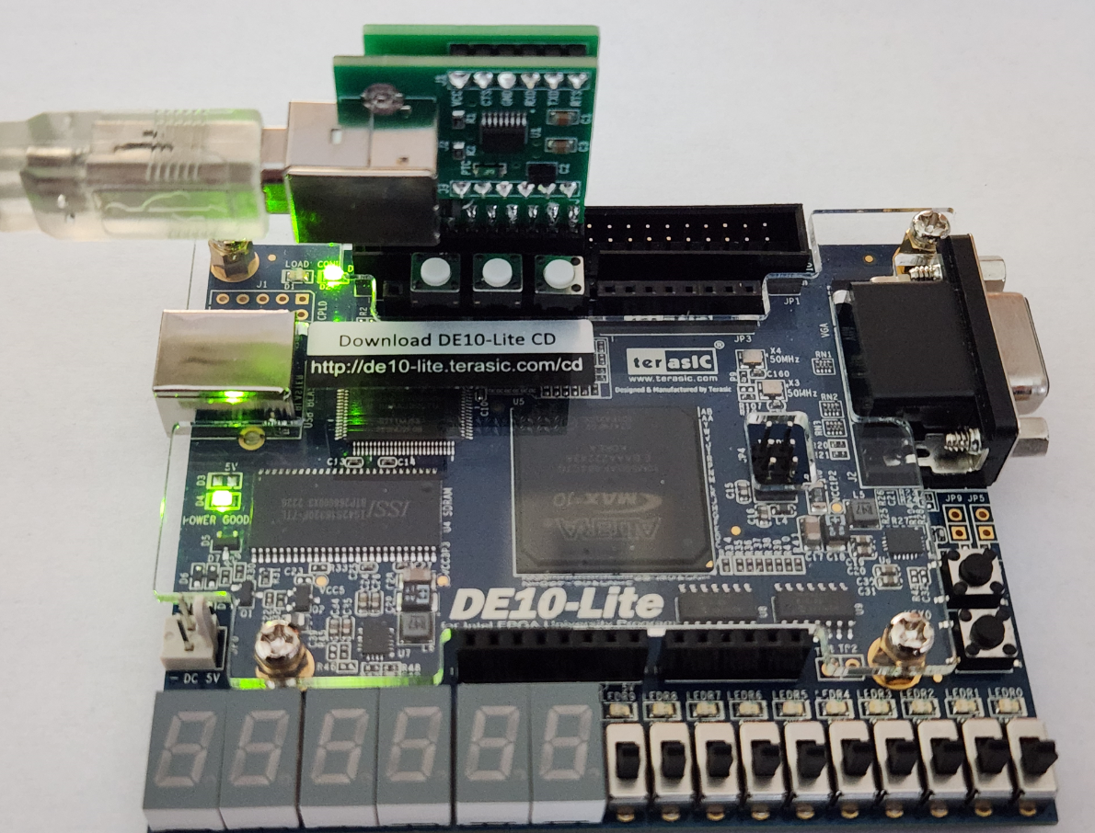
USB to Serial with GPIO Dupont Wires and Breadboard
It is possible to connect the DE10-Lite board to the USB adapter using Dupont wires and a bread board as shown in the image below. This is functionally equivalent to using the GPIO adapter board.
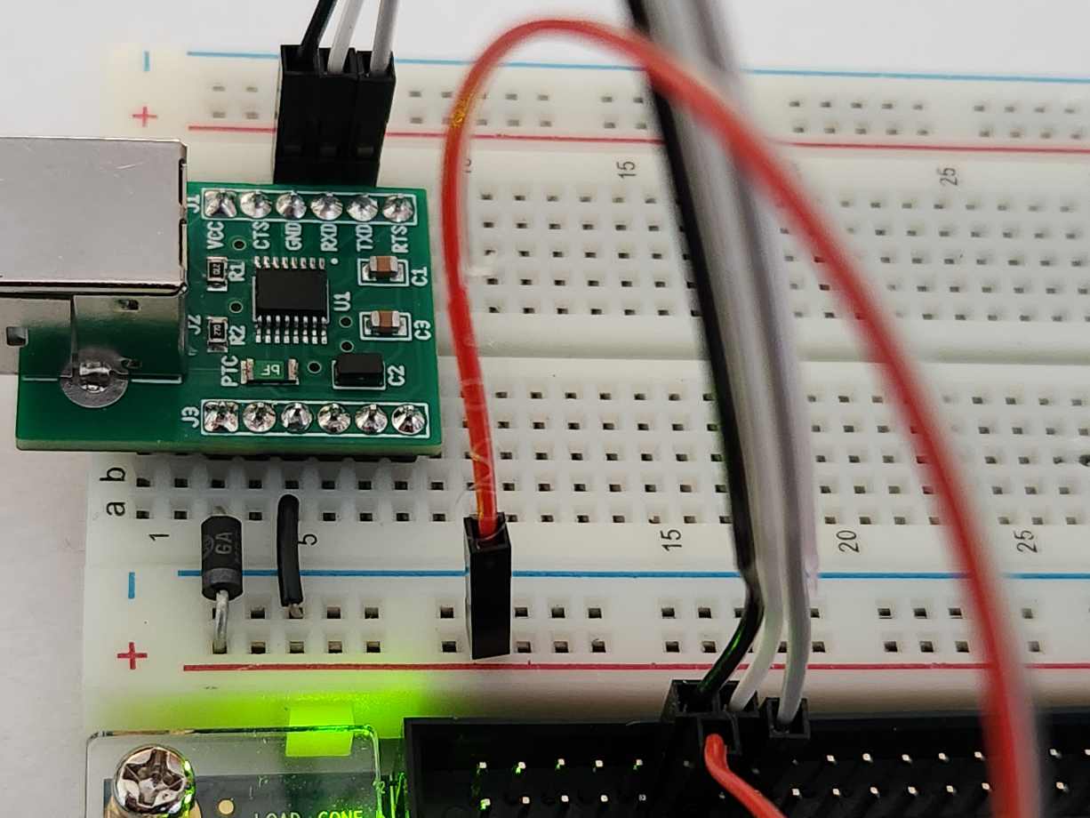
In the image above we have the following connections:
Either pin 1 of J3 or pin 1 of J1 in the USB adapter outputs 5V. This 5V connects to the 5V of the DE10Lite board using a MBR150 Schottky diode to pin 11 of connector GPIO.
Either pin 3 of J3 or pin 3 of J1 in the USB adapter is reference ground. This ground connects to the ground of the DE10Lite directly to pin 12 of connector GPIO.
Pin 4 of J1 in the USB adapter is the RXD pin that connects to pin 14 of connector GPIO in the DE10-Lite board.
Pin 5 of J1 in the USB adapter is the TXD pin that connects to pin 16 of connector GPIO in the DE10-Lite board.
Text Editor and Development Environment
Download and install VS Code for macOS from here:
https://code.visualstudio.com/Download
Open a terminal shell and install xcode using:
xcode-select --install
Download the file Mac.zip (It should be available on Canvas) and copy it to your home directory. Open a terminal shell and type:
unzip Mac.zip
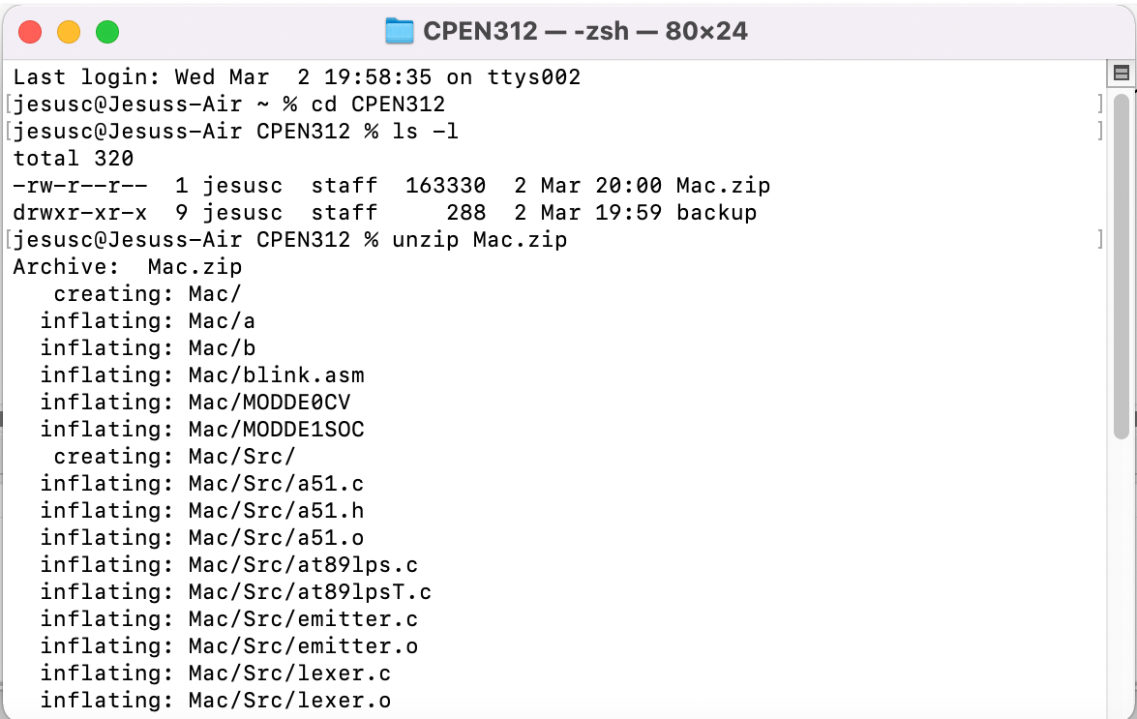
We need to build the assembler compiler and the flash loader. First change to the directory Mac/src, where the source files are:
cd Mac
cd src
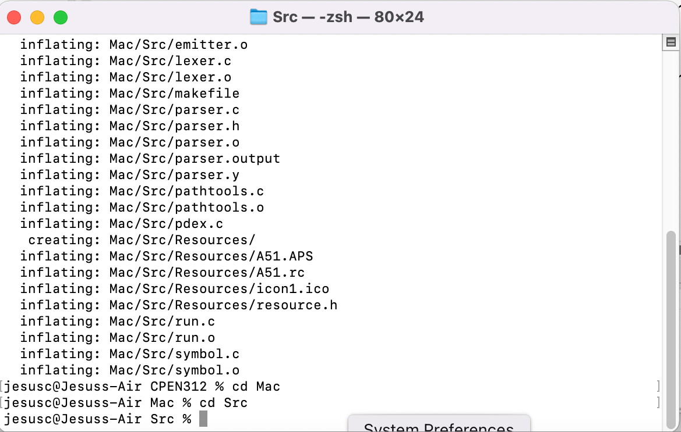
Then type to build the assembler compiler and flash loader:
make
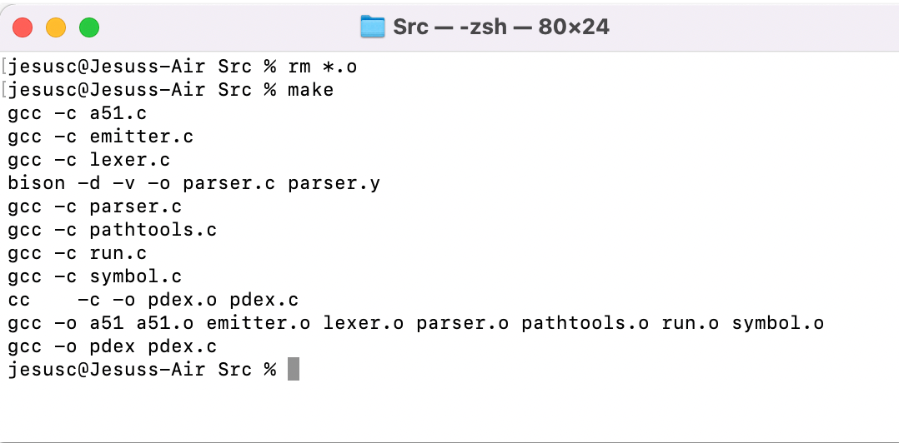
Now we copy the two newly created tools (a51: assembler compiler; pdex: flash loader) to the working directory, where the source files (.asm) are. The file ‘MODDE0CV’ must also be in the same folder.
cp a51 ../
cp pdex ../
cd ..
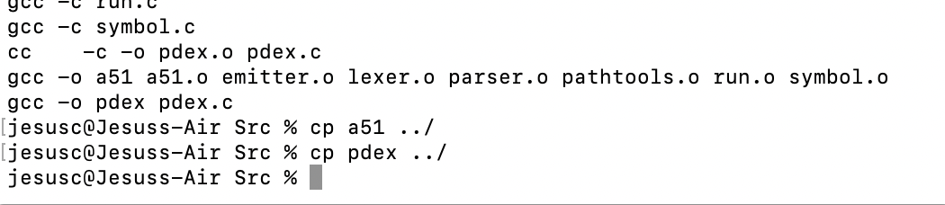
To compile using the 8051 assembler, in the terminal shell type:
./a51 -l blinky.asm
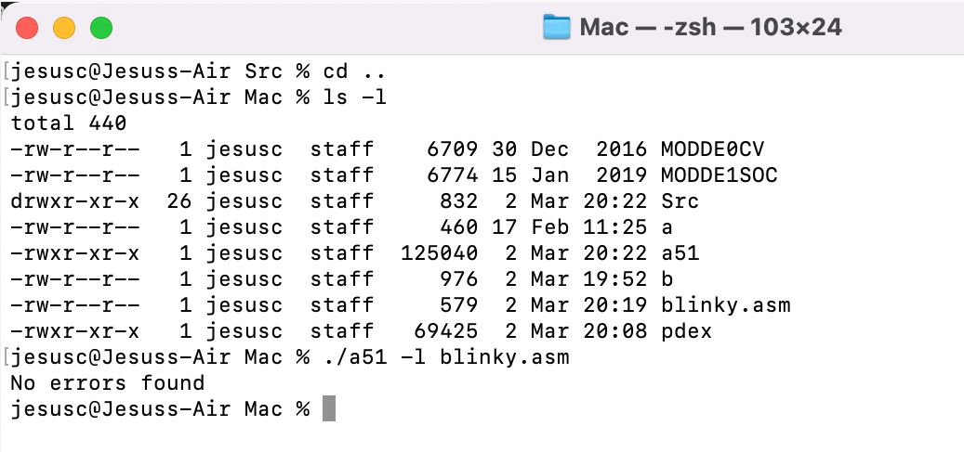
To load to the CV-8052 soft processor, first press and hold the KEY0 push button, press and release the RESET button, then release the KEY0 push button. The board enters boot mode. First we need to find the name assigned by macOS to the USB serial port adapter. To do so, in a terminal shell type:
ls -l /dev/ | grep "usb"
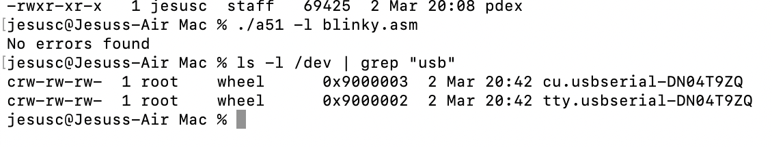
That will give you the two names of the usb-to-serial port assigned by macOS for the BO230XS adapter. The names are different for different BO230XS adapters. In one of my computers one of the names returned was cu.usbserial-DN04T9ZQ as shown above. Now call the loader to send the compiled object of the program to the board (notice the "-p/dev/"):
./pdex -p/dev/cu.usbserial-DN04T9ZQ blinky.hex
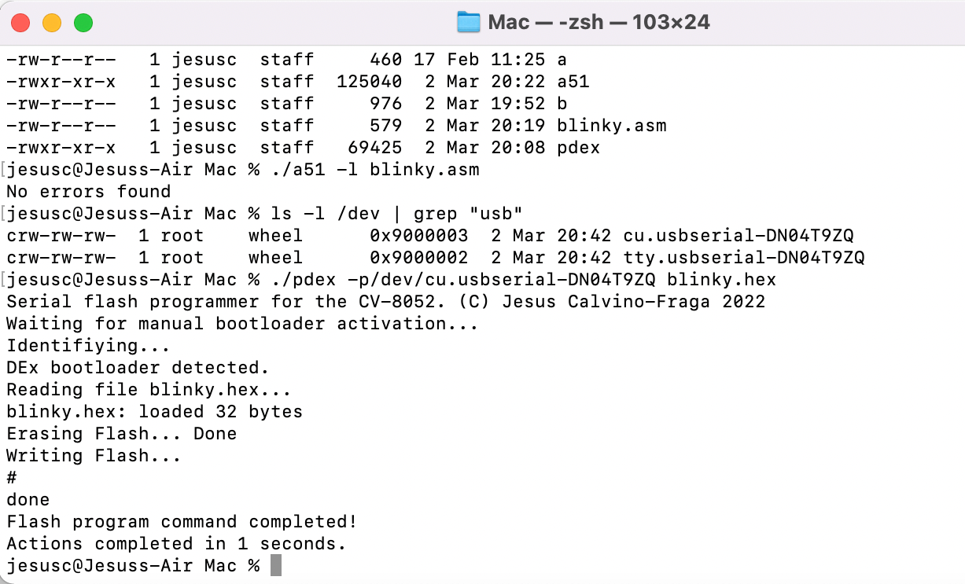
These tasks can be also performed in the terminal of VS Code, while having access to the source code for edition. You should first install syntax highlighting for the 8051 assembler in VS Code:
Run VS Code, and click 'Open folder...":
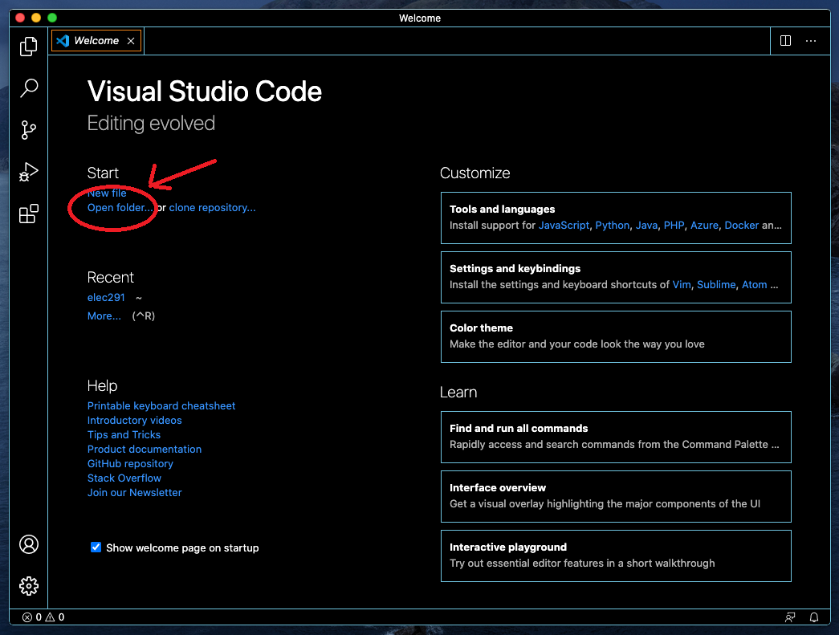
Select the folder where your source files are located. To install syntax highlighting for the 8051, click the extension button:
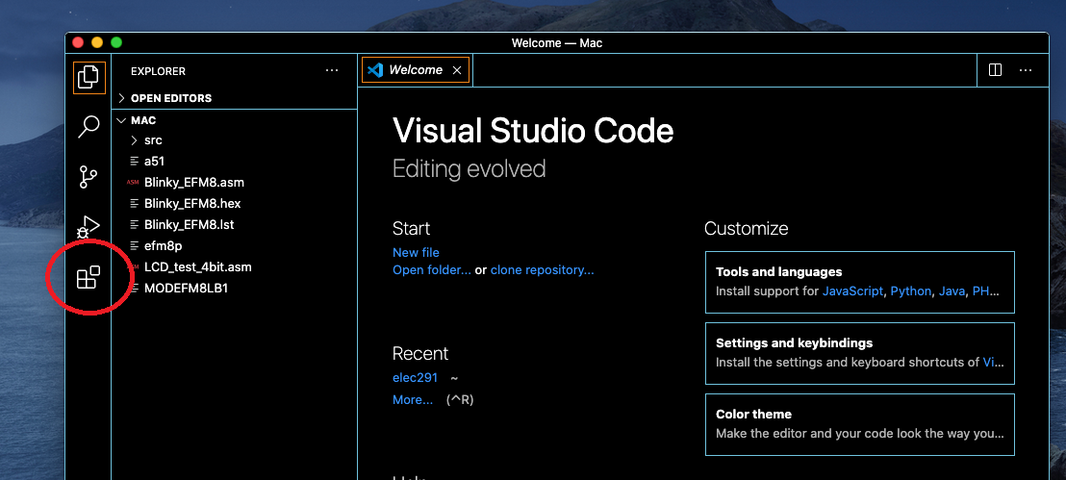
Type "8051" and pick the first one. The others may work also but I hadn’t tried.
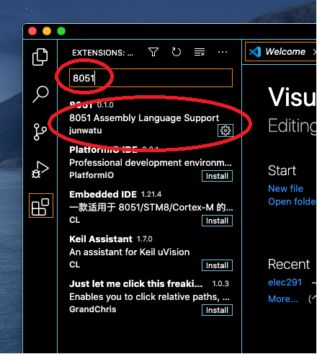
Click the explorer button and the double click the ".asm" file you want to edit. The file opens and we can make changes:
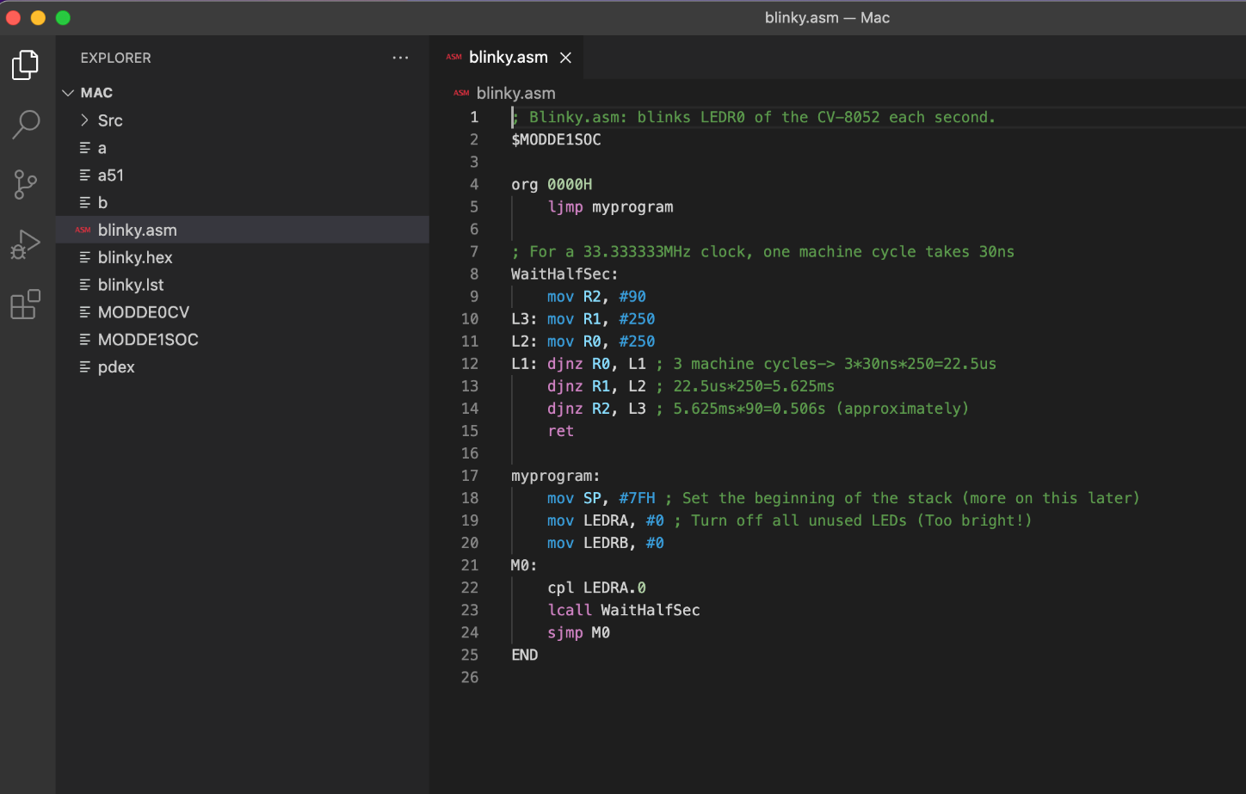
To compile click the "Terminal" menu entry, and them "New Terminal":
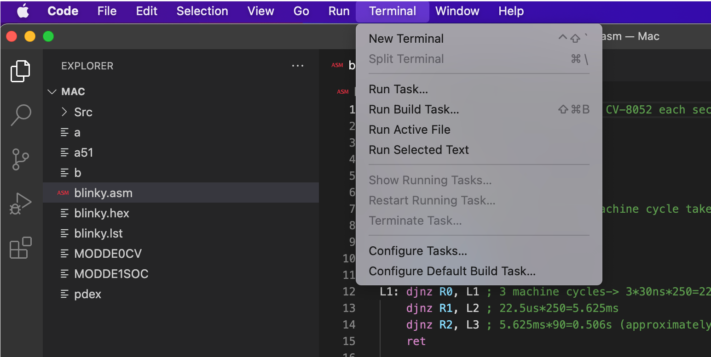
A terminal shell opens inside VS Code. From there we can compile the source code and load the memory of the CV-8052 processor using the generated “hex” file and the program ‘pdex’. Let us compile first as before:
./a51 –l blinky.asm
Before loading, we need to activate the boot-loader: first press and hold the KEY0 push button, press and release the RESET button, then release the KEY0 push button. Then run the loader program as before:
./pdex -p/dev/cu.usbserial-DN04T9ZQ blinky.hex
The image below shows the results in the terminal of VS Code.
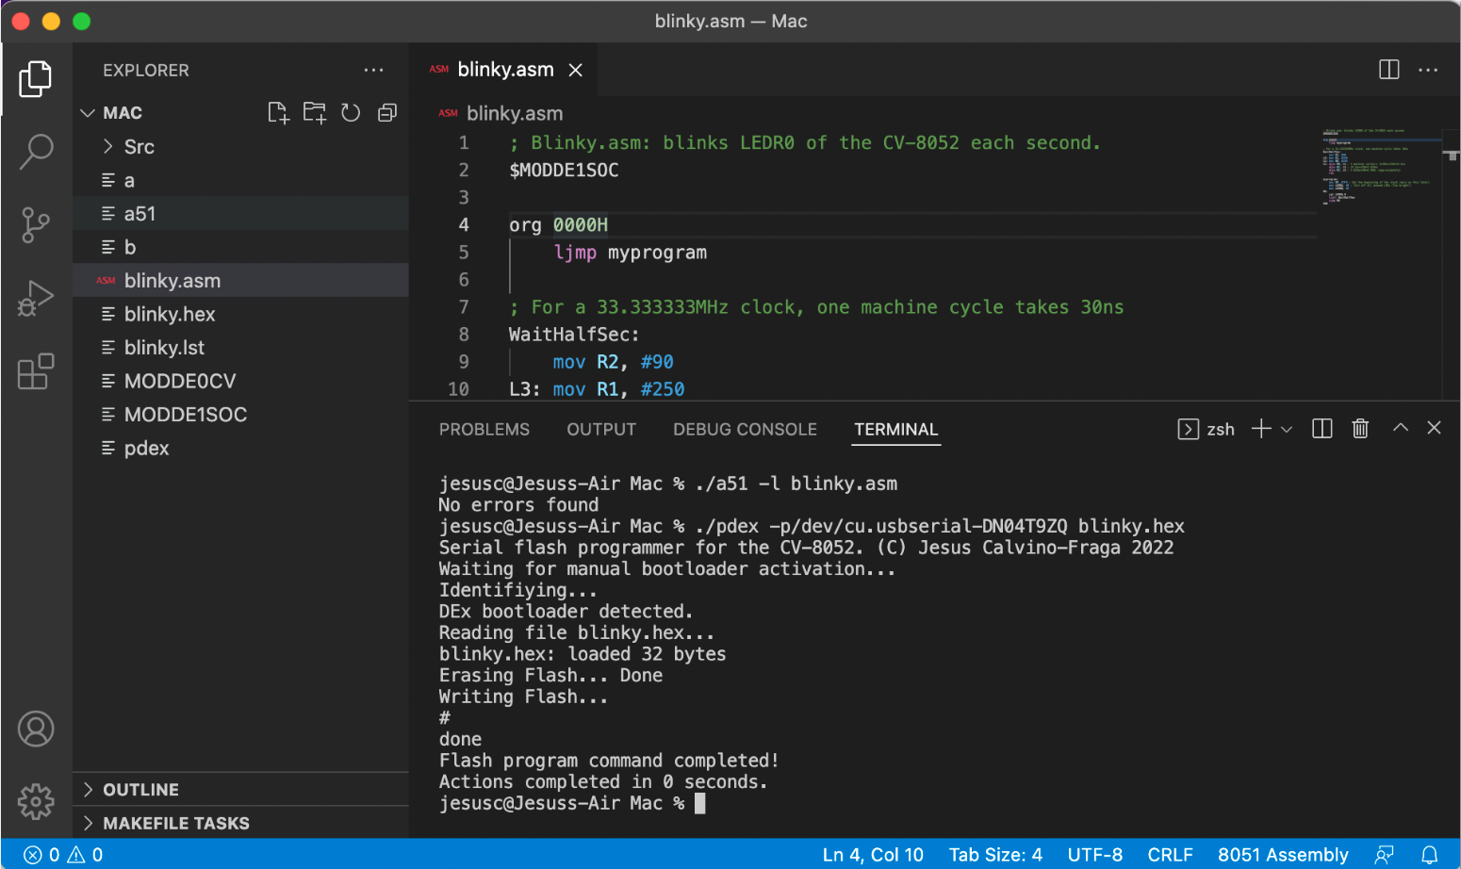
Since compiling and loading are very repetitive tasks, you should consider writing a couple of shell scripts to speed up the process. These two scripts can be used to quickly compile the source “asm” file and load the resulting “hex” file to the CV-8052 soft processor:
Script 1, for compiling:
#!/bin/bash
prompt="Please select a file to compile:"
options=( $(find *.asm | xargs -0) )

PS3="$prompt "
echo ""
select opt in "${options[@]}" "Quit" ; do
if (( REPLY == 1 + ${#options[@]} )) ; then
exit

elif (( REPLY > 0 && REPLY <= ${#options[@]} )) ; then
echo "Compiling $opt"
./a51 -l $opt
break

else
echo "Invalid option. Try another one."
fi
done
echo ""
Script 2, for loading:
#!/bin/bash
prompt="Select usb to serial port:"
options=( $(find /dev/*cu.usbserial* | xargs -0) )

if (( ${#options[@]} == 1 )) ; then
opt1=$options
echo "Using $options"
else
PS3="$prompt "
echo ""
select opt1 in "${options[@]}" "Quit" ; do
if (( REPLY == 1 + ${#options[@]} )) ; then
exit

elif (( REPLY > 0 && REPLY <= ${#options[@]} )) ; then
echo "Selected usb to serial: $opt1"
break

else
echo "Invalid option. Try another one."
fi
done
fi

prompt="Select hex file:"
options=( $(find *.hex | xargs -0) )

PS3="$prompt "
echo ""
select opt2 in "${options[@]}" "Quit" ; do
if (( REPLY == 1 + ${#options[@]} )) ; then
exit

elif (( REPLY > 0 && REPLY <= ${#options[@]} )) ; then
echo "Selected hex file: $opt2"
./pdex -p$opt1 $opt2
break

else
echo "Invalid option. Try another one."
fi
done

echo ""
I named the scripts “a” and “b”. You’ll need to change the mode of the scripts so they can be executed:

chmod a+x a
chmod a+x b
This is how the scripts look like when called from VS Code:
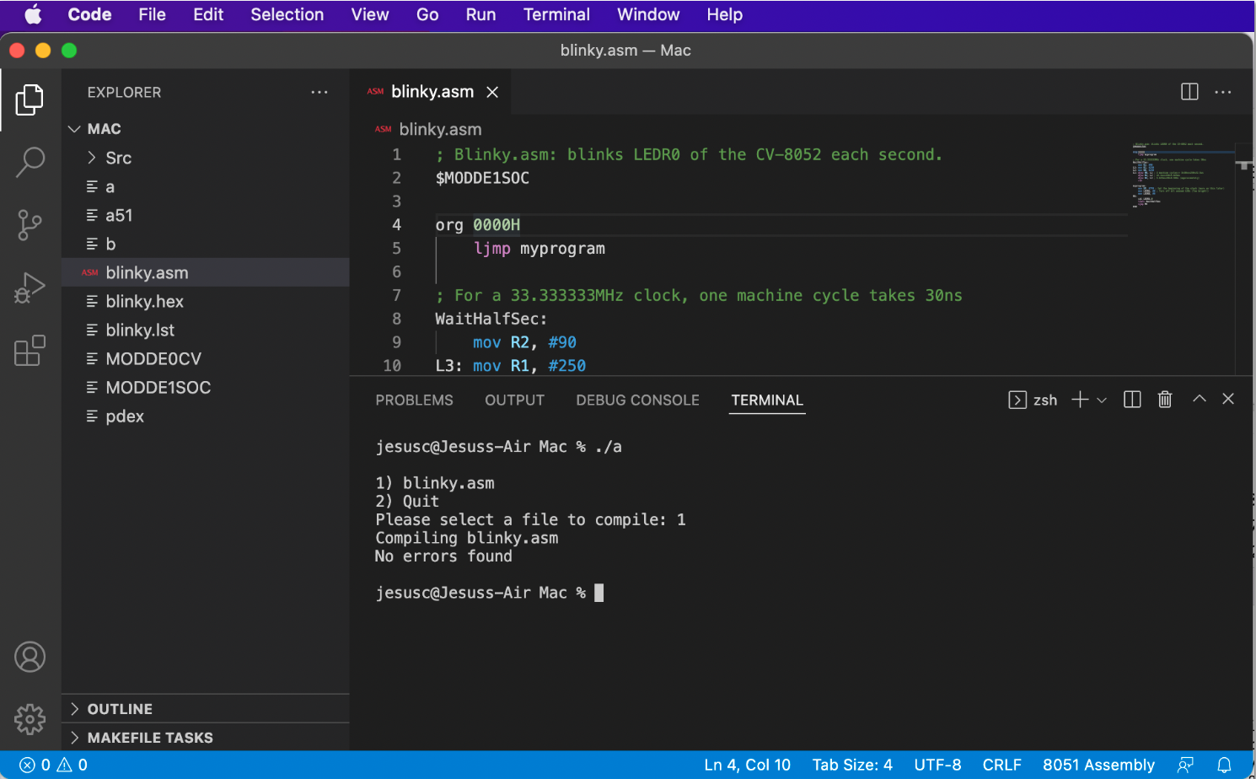
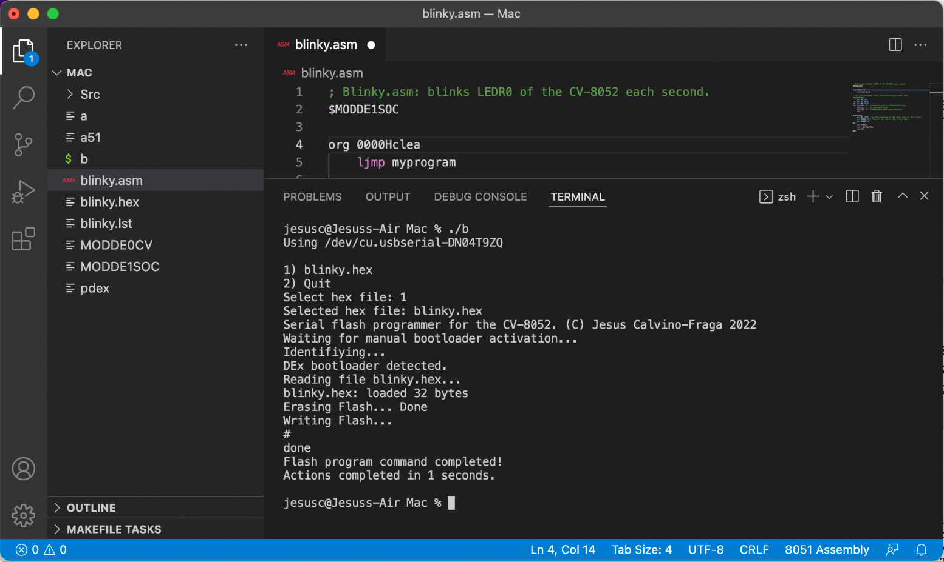

In the latest version of pdex, the option ‘-a’ is available. This option automatically directs pdex to use the first USB to serial adapter it finds without requiring the explicit name assigned to the device by macOS. For example: ./pdex -a blinky.hex

